**CS7CS3 Advanced Software Engineering Group Project**

**Functional and Technical Architecture**

**Project Name: Sustainable City Management**

**Group 5**

**Group Members:**

|  |  |  |  |
| --- | --- | --- | --- |
| Yatheendra Pravan K M 20305901 | Lokesh Selvakumar 21331969 | Karina Salem 20323363 | Kevin Reynolds 20308229 |
| Kalaivani Kandasamy 21332195 | Deeksha Vyas 21334447 | Ayush Kalra  20327429 | Shubham Maurya 20310455 |

Contents

1. Functional Architecture 2

*1.1.* *Diagram* 2

*1.2.* *Component Descriptions* 2

*1.3.* *Component interactions* 2

*1.4.* *Component APIs* 3

2. Technical Architecture 3

*2.1.* *Diagram* 3

*2.2.* *Quality of Service Technical Requirements* 4

# Functional Architecture

### *Diagram*

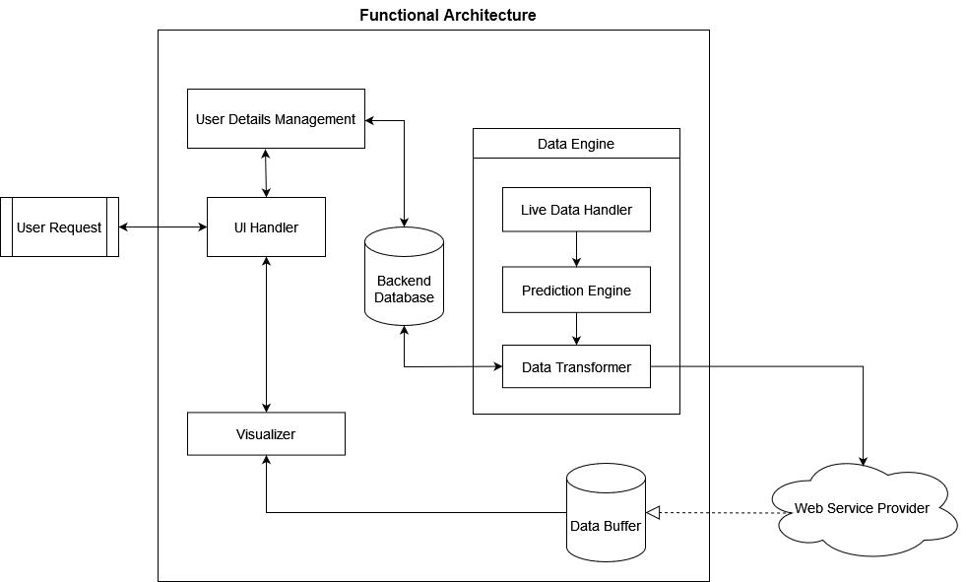

### *Component Descriptions*

*<Section 1.2. should include a textual description of each component in the functional architecture, including a list of its responsibilities.>*

**User Details Management**

This component will be responsible for user sign up, verification of the login details of the city managers, as well as managing the roles for the different users’ types.

**User Interface (UI) Handler**

This component will be handling the user interactions with the interface. It will also be responsible for the display and the user experience (UX).

**Data Engine**

Every five minutes, the engine will fetch live data and perform the functionality specified in the following three sub-components:

1. Live Data Handler: it will dynamically select the API end-points, fetch live data from those sources, and pass it to the Prediction Engine.
2. Prediction Engine: It makes predictions from the live data and passes the predicted data to the data transformer.
3. Data Transformer: It receives data from the Predication Engine and performs the following:
4. Converts the received raw data to a data format compatible with the visualization components such as heat maps, bar charts, etc.
5. Estimates and calculates from the received data for:
6. The Luas energy usage estimation.
7. The bicycle station estimates station usage, station capacity report and station swap suggestions.
8. The bus estimates predict bus locations, calculate the emissions report and calculate alternative route suggestions based on CO2 emissions and congestion factors.
9. The events/incidents include the crowd estimates, bus route suggestions based on events, weather-warning reports and maintenance logging for each transport type.
10. The Data Transformer reads the aggregated and historical data from the Backend Database and then re-writes the newly computed data into it.

Then, the Data Transformer sends the aggregated and transformed data to the Web Service Provider.

**Backend Database**

It will store the user information and the aggregated and historical data that would be used by the Data Transformer.

**Web Service Provider**

It will implement the Publisher Subscriber Model using Firebase; whenever the Data Engine sends new data it will pass it to the Data Buffer.

**Data Buffer**

It will store the transformed data for all the data indicators. The transformed data includes both the live data and predictions. When the user if offline, this Data Buffer would be used to access predicted data.

**Visualizer**

 It is responsible for displaying a different set of visualization for each data indicator in our system - Bicycles, Buses, Luas, and Events/Incidents. It will retrieve the data from the data buffer based on the system time.

### *Component interactions*

*<Section 1.3. should include a* ***UML Sequence Diagram*** *for* ***each use case*** *in your Use Case document, indicating how the components in your functional architecture interact with each other to achieve the use case. Use API names, which will be described in more detail in section 1.4. Include basic flow and all alternative flows from the Use Case descriptions.>*

**Use Case 1 Name**

*<add sequence diagram(s)>*

**Use Case 2 Name**

*<add sequence diagram(s)>*

*<and so on for all Use Cases>*

### *Component APIs*

*<Section 1.4. should include a* ***List of the APIs ( < return parameter API-name( input parameters) >)*** *and a description of the responsibilities of that API for each component>*

**Component 1 Name**

* *Return-parameter API-Name1( input parameters )*

*Description of responsibilities of the API*

* *Return-parameter API-Name2( input parameters )*

*Description of responsibilities of the API*

* *Return-parameter API-Name3( input parameters )*

*Description of responsibilities of the API*

* …..

**Component 2 Name**

* *Return-parameter API-Name1( input parameters )*

*Description of responsibilities of the API*

* *Return-parameter API-Name2( input parameters )*

*Description of responsibilities of the API*

* *Return-parameter API-Name3( input parameters )*

*Description of responsibilities of the API*

* …..

*<and so on for all components>*

# Technical Architecture

### *Diagram*

*Please include a Technical Architecture Diagram. Include:*

* *an indication of the network to be used*
* *an indication of how/where the functional architecture components will be placed/deployed*
* *an indication of what technologies will be used in all parts of the technical architecture.*
* *an indication of what development technologies will be used*

*Diagram here.*

### *Quality of Service Technical Requirements*

*Indicate whether, and to what extent, your project will address the following requirements, considering all the actors, and* ***indicate how the technical architecture will address any impact****.*

**Security Requirements**

|  |  |
| --- | --- |
| ***Security Requirement*** | ***Impact on Project and how the Technical Architecture will address the impact*** |
| Encryption  - Do transactions need to be encrypted?  - Level of encryption? (e.g., 40-bit encryption in US) |  |
| User Identification  - uid/pw, cookies, certificates, application-level?  - Existing customer database that should be used to identify online visitors? |  |
| Access to data  - Do you need to restrict access to parts of the site?  - What privacy rules should be applied to information provided by users |  |
| What are the legal requirements and policies for auditing content, changes and transactions? |  |
| Do you plan to use a secure demilitarised zone into which your project server code could be placed? |  |

**System Management**

|  |  |
| --- | --- |
| ***System Management Requirement*** | ***Impact on Project and how the Technical Architecture will address the impact*** |
| Do you have access to the infrastructure required to install and run you own server? |  |
| What are the response time targets? |  |
| ***Availability*:**  - What hours should the service be available?  - Is it acceptable to have any scheduled downtime for maintenance?  - How important is it that the service be never interrupted, even for unscheduled component failures?  - If interruptions do occur, what should be the target time for resuming service? |  |
| How should partial or total service failures be monitored and handled? |  |
| Do you need a recovery plan, or will it be covered by existing processes? |  |
| ***Tracking/Documenting:***  How should the architecture support the process of problem reporting, tracking and fixing?  What statistics do you need to keep about the site, and how will they be analysed?  What instrumentation should be included in the design to measure performance, response times and availability?  Should the architecture include a repository for statistical data? |  |

**Client-side Management**

|  |  |
| --- | --- |
| ***Client-side Management Requirement*** | ***Impact on Project and how the Technical Architecture will address the impact*** |
| Who is the customer? (Internet or Intranet) – affects browser choice |  |
| What is the level of the user’s skill? |  |
| What languages should the site support? |  |
| What are the user’s usage patterns? (search or browse) |  |
| How will the application maintain state? |  |
| Is there a need to distribute application code, and if so, how will it be done? |  |
| How will the choice of client affect end-to-end response? (HTML, JavaScript, AJAX, JQuery, VBScript?) |  |
| What are the different user interfaces needed? |  |

**Network Management**

|  |  |
| --- | --- |
| ***Network Management Requirement*** | ***Impact on Project and how the Technical Architecture will address the impact*** |
| Will the solution involve the internet?  What protocols will be used? (*HTTP? HTTPS? FTP? RMI? Messaging? Etc)* |  |
| What about data, object and application placement?  *projected transaction volumes, amount of data, interaction?* |  |
| What security functions are required/provided by chosen protocol?  *Ievel of encryption will affect this, and also performance!* |  |
| How does the network affect end-to-end response time? |  |

**Server-side Management**

|  |  |
| --- | --- |
| ***Server-side Management Requirement*** | ***Impact on Project and how the Technical Architecture will address the impact*** |
| Single server or multiple servers? Peer-to-Peer? Sensors? |  |
| Geographic location for servers? |  |
| End-user client to server, or server to server required also? |  |
| What security functions are required on the server? |  |
| How can impact of server on end-to-end response time be estimated, and catered for in the architecture? |  |

**Application Logic**

|  |  |
| --- | --- |
| ***Server-side Management Requirement*** | ***Impact on Project and how the Technical Architecture will address the impact*** |
| Will site use client-side executables? What are their connectivity requirements? |  |
| How will application be split between client-side and server-side logic? (*affects communications for validation etc/performance?*) |  |
| Additional access security required? |  |

**Connectors**

|  |  |
| --- | --- |
| ***Server-side Management Requirement*** | ***Impact on Project and how the Technical Architecture will address the impact*** |
| What external systems, applications and (sensor) data does your project need to access? |  |
| How should data be transferred between different systems? |  |
| How current does the information have to be? *Use caches?* |  |
| Is synchronous or asynchronous access required? *Off-line OK?* |  |
| Is access to different operating systems, network protocols, application environments required? *which connector? CICS? MQSeries? RPC?* |  |
| Are additional security policies required? |  |
| Can scalability and performance requirements be predicted, and how will the project address these? |  |